**6.3 Similarity Solving Practice**

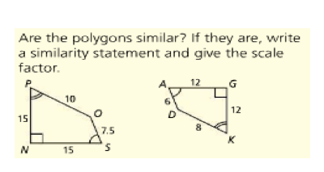**1.** Similarity Statement:

_____________ ~ _____________

Scale Factor:

_______________

Complete the sentence: The polygons in question 1 are similar because...  _____________________________ and _______________________________________________

**2.   
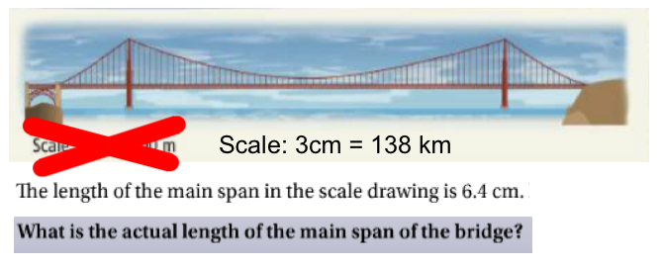**

**3.** Find the missing length. The triangles in each pair are similar.

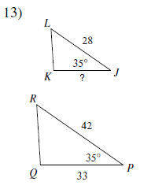

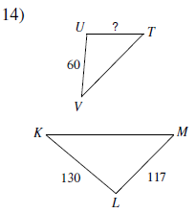

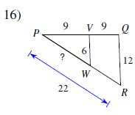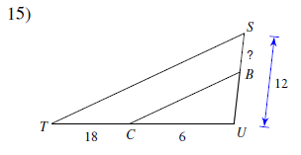

**4.**

